INFO: Created TensorFlow Lite XNNPACK delegate for CPU.
1. [163] beagle: 0.375703
2. [162] basset: 0.257297
3. [167] Walker hound: 0.230607
4. [164] bloodhound: 0.063243
5. [168] English foxhound: 0.053693
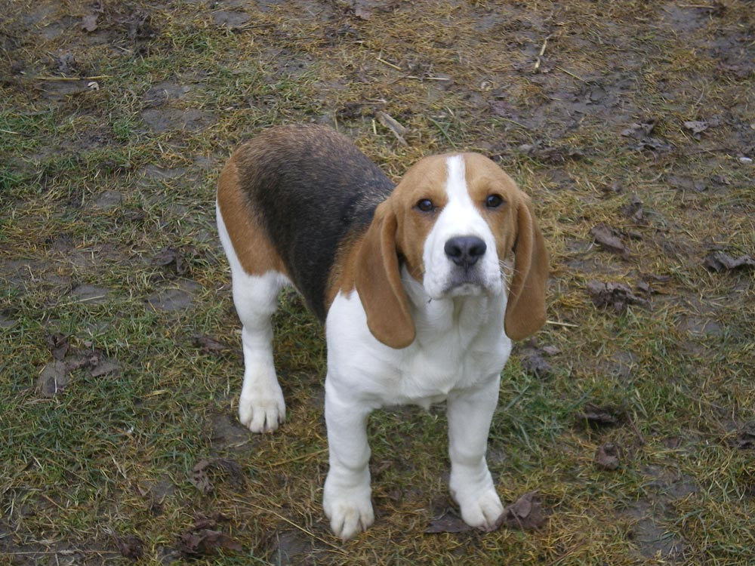
(.venv) alfaquillo@quillo-thinkpad:~/tools/minitalleres/Minitaller_TensorFlowLite$

